Prometheus Workshop Breakout 1:

**Exploring the UI**

## Getting Started

Prometheus Server endpoint

<http://104.131.10.78:9090>

[http://104.131.10.78:9090](http://104.131.10.78:9090/)

Connect to this URL in your web browser. You'll be presented with the Prometheus UI which contains four tabs across the top:

Alerts Graph Status Help

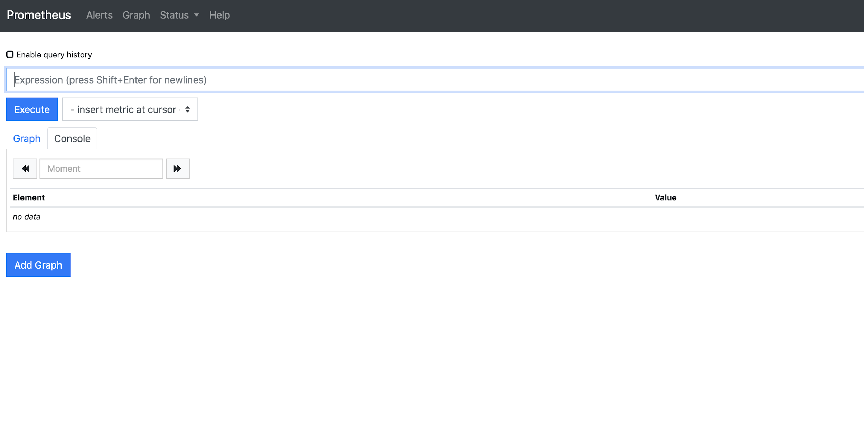

* By default, you'll see the **Graph** tab which contains a query box.
* Go to the **Alerts** tab where you will see we have configured a few alerts. Take a look at the ones listed--does anything stand out?
* Go to the **Status** tab. This contains a sub menu you can poke around in.
  + The first one I would visit is the **Targets** page; this tells us what's been configured in the Prometheus server. These jobs are what we defined in the prometheus server yml config. They will either be up or down.
  + Review **runtime and build information**
  + *The* ***Configuration*** *page will present a similar configuration we just went over, with a bit more targets added.*

## Node Exporter

[Node exporter](https://github.com/prometheus/node_exporter) is running on the endpoint below and we can check the metrics by visiting its /metrics endpoint:

<http://104.131.10.78:9100/metrics>

## Alertmanager UI

<http://104.131.10.78:9093>

Visit the URL and take a look at the [Alertmanager UI](https://github.com/prometheus/alertmanager). The Alertmanager handles alerts sent by the Prometheus server. It takes care of deduplicating, grouping, and routing them to the correct receiver integration such as email, PagerDuty, or OpsGenie. We will briefly go over the Alertmanager later in our workshop so don’t worry too much about the details of Alertmanager right now. We just want you to know the UI is available to you.

## Querying

Let's go back to the Prometheus server [webpage](http://104.131.10.78:9090) to graph a few queries using the Prometheus query language, [PromQL](https://prometheus.io/docs/prometheus/latest/querying/basics/).

You can use the drop-down field next to the **Execute** button (*insert metric at cursor*) to start finding metrics to visualize. Or, simply begin typing a metric name and find your metric name using the autofill feature:

**

Let’s take a look at the up metric. Type it into the query box and click **Execute**.

The up metric is probably the most popular query to run. It gives you a value of 1 (up) or 0 (down) and lets you know which jobs are running. Besides using the [targets](http://104.131.10.78:9090/targets) page under the **Status** tab in the Prometheus UI, this is the quickest way to know what is up.

In preparation for our second breakout, we will be using metric names that start with tns_. Let’s take a look at a few examples.

tns_client_request_duration_seconds_count{job="tns-app", status_code="500"}

This metric tells us client request duration and looks for the label status_code with a value of 500. Take a look at the **Graph** tab--do you notice anything interesting?

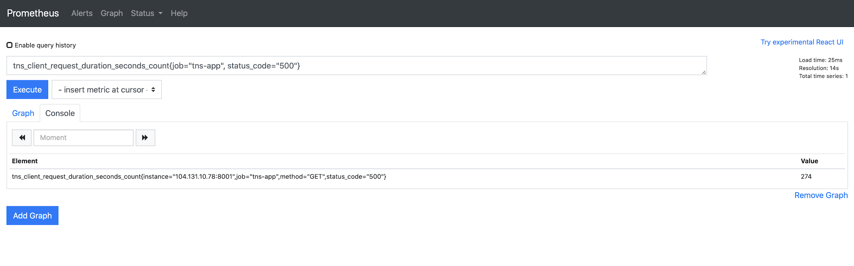

Try removing the labels. What do you see?

Let's look at some node exporter specific metrics:

node_cpu_seconds_total

*This tells us how many seconds each CPU spent doing each type of work (such as* mode="idle"*, time when the CPU had nothing to do). This metric is coming from the* /proc/stat*.*

Try switching from the **Console** output to **Graph** visualization to get a feel for the Prometheus graphing capabilities.

*Zoom out by clicking the + sign to add more time to the Graph. Switch back and forth between the two as you try the queries below.*

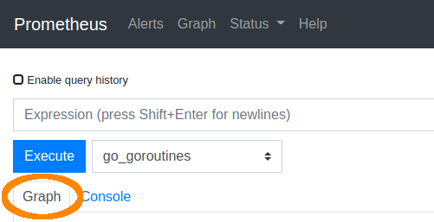

node_cpu_seconds_total{mode="system"}

*This tells us the time spent in the kernel.*

irate(node_cpu_seconds_total{job="node"}[5m])

*We have not discussed counters and query functions yet, but to give you a quick example, we are taking a counter and calculating the per second values using the* irate *function.*

rate(node_network_receive_bytes_total[1m])

*This tells us each network device's statistics for received bytes. This is also a counter type of metric.*

count by(mode) (node_cpu_seconds_total)

*We will go more into PromQL in the next section but as a preview, if you break down this query, it is counting the number of elements in this vector broken down by mode.*

*Count Count*

*Since we aren't visualizing metrics in Grafana yet (and therefore, aren’t able to set a value unit such as percentage), let’s see what the total CPU usage is in terms of percentage:*

100 - (avg by (instance) (irate(node_cpu_seconds_total{job="node",mode="idle"}[5m])) * 100)

Challenge: What do you think this query is telling us?

1-(node_filesystem_free_bytes{fstype=~"ext4|xfs"} / node_filesystem_size_bytes{fstype=~"ext4|xfs"})

## Pop Quiz

What query would you use to find the Prometheus build info?

How many time series does this Prometheus server have?

*End of first breakout, stop here*

Prometheus Workshop Breakout 2:

**PromQL & Dashboarding**

*An email was sent out a few days ago inviting you to grafana.com. We have provisioned a trial of our hosted services for the PromQL and dashboarding hands-on section.*

Visit grafana.com and sign in to access your hosted Grafana instance or log in to your hosted Grafana instance directly (https://YourInstanceExampleURL.grafana.net).

Once logged into grafana.com, you'll be presented with your stack. Click the **Log in** button in the Grafana section:

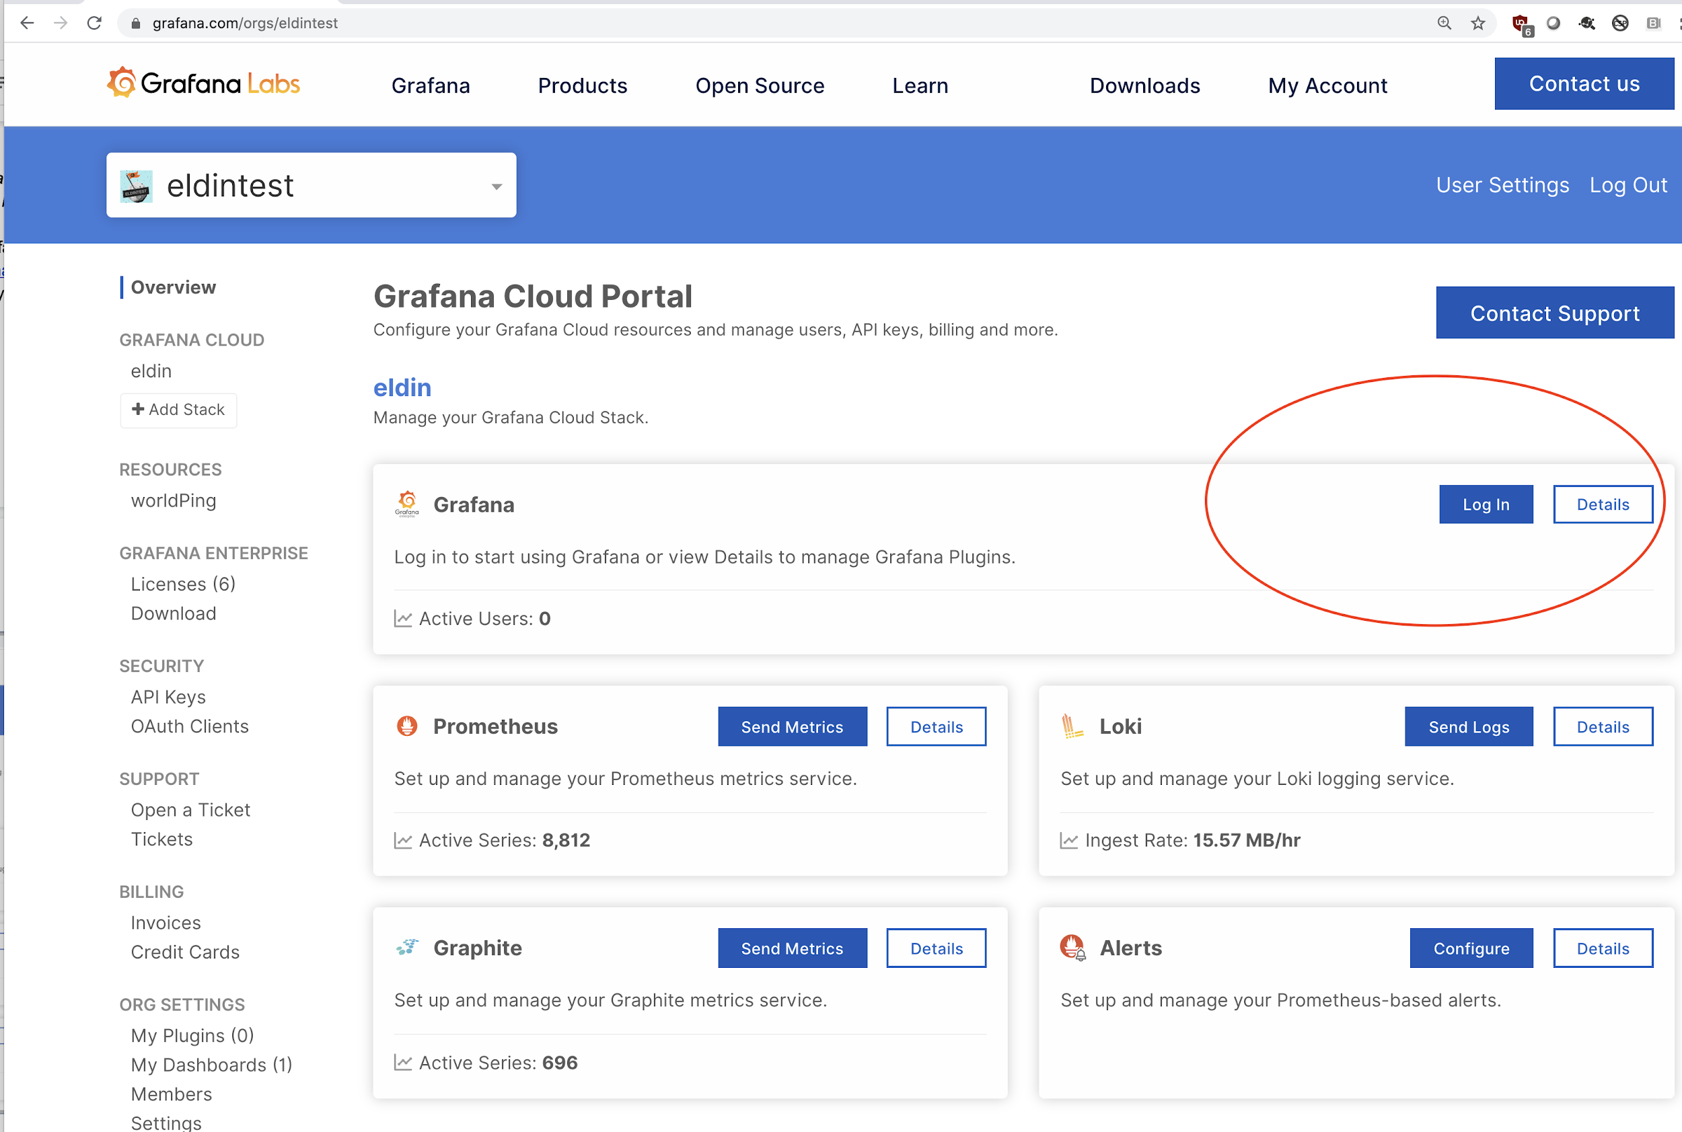

## Adding a Prometheus Data Source

Once you are signed into your instance, let's visit the data source section and add one.

On the left hand side, at the bottom of the menu bar, go to the settings gear -> **Data Sources**.

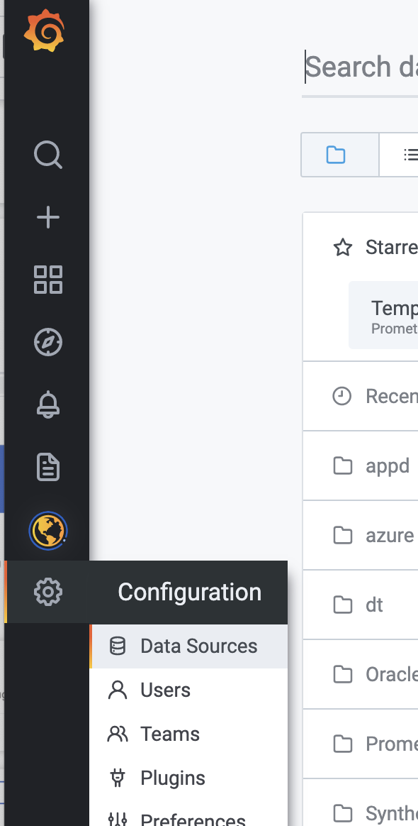

On the top right, click the **Add data source** button. Select the Prometheus data source.

Name the data source workshop.

For the URL input, use <http://104.131.10.78:9090/>.

Click **Save & Test** to confirm your Prometheus data source was added correctly.

Great! We’ve just added the Prometheus data source that we used in the first breakout session.

Grafana’s dashboard UI is all about building dashboards for visualization while the **Explore** view strips away all the dashboard and panel options so you can focus on the query.

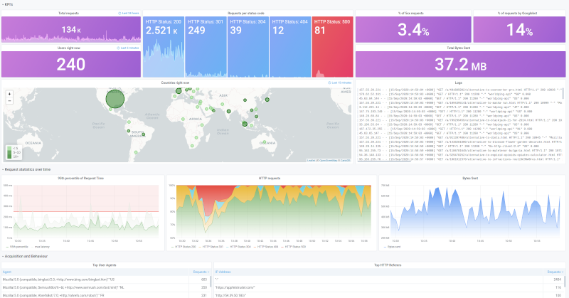

*Dashboard view*

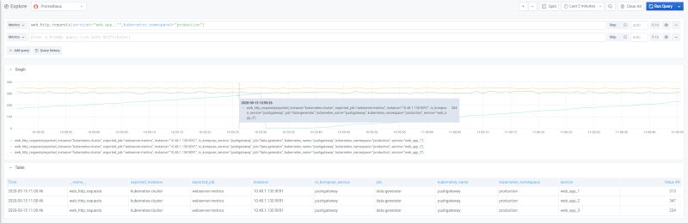

*Explore view*

In this workshop, we will apply the things we learned by writing a query first to get some data back. Once we have established our query, we can create a dashboard with visualization panels and saved queries.

## Using the Explore View

To write a query in the Explore view, click on the **Explore** icon in the navbar on the left.

Now that we are in the Explore view, make sure the workshop data source is selected on the top left.

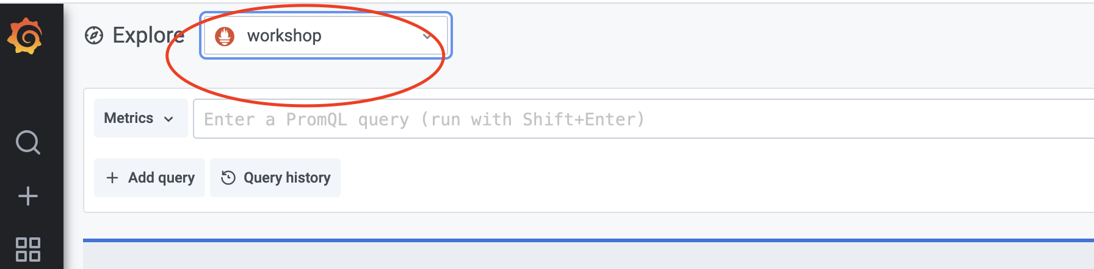

First, use the drop-down to explore some of the metrics available to us. Looks familiar, right?



The query we want to start off with is tns_request_duration_seconds_count*.*

*Tip: Instead of clicking the* ***Run Query*** *button, you can use the shortcut shift + enter | ctrl + enter.*

This query is telling us the count of the number of requests. It will list all jobs.

Let’s focus on a specific job, tns-app.

Apply the job label:

tns_request_duration_seconds_count{job="tns-app"}

We can see the instance and job names are the same but we have a few different methods and status codes.

Let's turn this raw counter data into something useful. If you remember, counters are ever increasing unless reset.

Before we add the rate() query function, let’s use the time picker to go back a few days to see how the time series is ever increasing.

Time to add the rate() query function!

rate(tns_request_duration_seconds_count{job="tns-app"})

Oh no! Error. We forgot the time window. Let’s try one minute:

rate(tns_request_duration_seconds_count{job="tns-app"}[1m])

There we go--now we are seeing something!

***Note:*** *When choosing the time value for rate, the time frame must be at least 4 times your scrape interval. In our example, we are scraping every 15 seconds so 1 minute is fine. But if we were scraping our targets every 30 seconds, we would want to make it at a minimum time frame of 2 minutes. You need at least 2 points to find the rate, but because scrapes could be missed, a safer bet is 4 points.*

## Queries in Practice

Let's do a quick aggregation. Because the sum query function only takes instant vectors and outputs instant vectors, the rate query function is nested inside the sum to turn the range vector into an instant vector for the sum aggregation.

sum(rate(tns_request_duration_seconds_count{job="tns-app"}[1m]))

Doing a quick aggregation, we can see there are about 11 to 12 queries/requests per second.

This is the request rate to this service. But what is more valuable for us is to know how many things are *failing*. So instead of all status codes, I want to filter out status codes that are not 2xx.

sum(rate(tns_request_duration_seconds_count{job="tns-app", status_code!~"2.."}[5m]))

Here, we are adding the label status_code with the label matching operator that selects labels that do not regex-match 2xx.

You should see some failures now!

Following Google’s SRE principles, we know that failure rates are not that useful or interesting. We want to know about the portion of total traffic that is failing.

So let's divide the failed requests by the number of total requests:

sum(rate(tns_request_duration_seconds_count{job="tns-app", status_code!~"2.."}[5m])) /

sum(rate(tns_request_duration_seconds_count{job="tns-app"}[5m]))

And let's change the rate from 5 minutes to 1 hour and add a multiplier so it's easier to read:

sum(rate(tns_request_duration_seconds_count{job="tns-app", status_code!~"2.."}[1h])) /

sum(rate(tns_request_duration_seconds_count{job="tns-app"}[1h])) * 100

Now, we begin to see something interesting. We can see that over the last hour, 16% of my requests are failing:

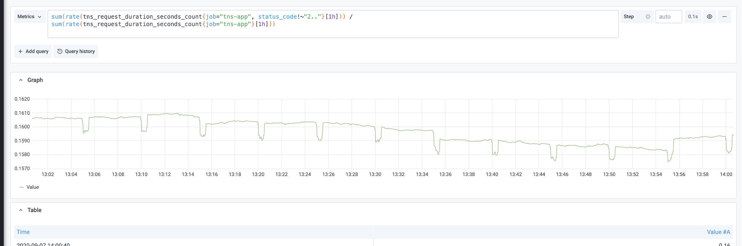

Taking a pause here to recap, what we have done is taken some raw counters and made it a more interesting query that can tell us what is failing.

To find which request method is failing, we can use a query like this:

sum by (method) (rate(tns_request_duration_seconds_count{job="tns-app", status_code!~"2.."}[1h])) /

sum by (method) (rate(tns_request_duration_seconds_count{job="tns-app"}[1h]))

*A PromQL gotcha is if you specify which label you care about in your query (by adding* by (<label>) *to either the nominator or denominator), you need to add the same to the other half of the fraction.*

It is recommended to always look at error rates by method so you can distinguish which route(s) is failing.

## 

## Building a RED Dashboard

We are going to build a dashboard with six panels:

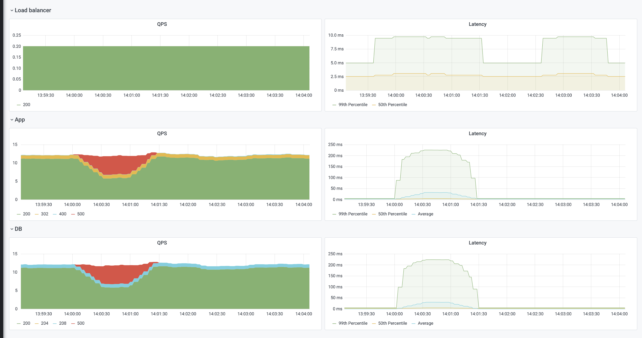

The dashboard is broken down by **Load balancer**, **App**, and **Database**.

To add a new dashboard, click on the **+** icon on the left hand side of the Grafana UI and click on **Dashboard**.

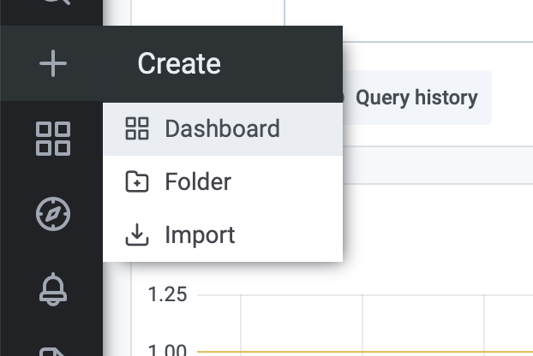

To add your first panel, click on the graph with the plus sign on the upper right:

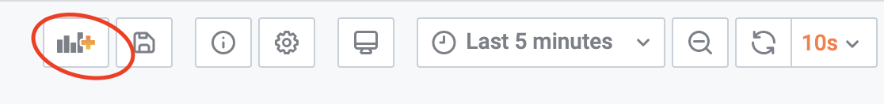

For your query, make sure you have selected your workshop data source. Input this query in the PromQL input field:

sum by (status_code) (rate(tns_request_duration_seconds_count{job="tns-loadgen"}[1m]))

Use these configurations:

**Legend**: {{status_code}}

**Settings**:

Panel title: QPS

**Display**:

Area Fill: 10

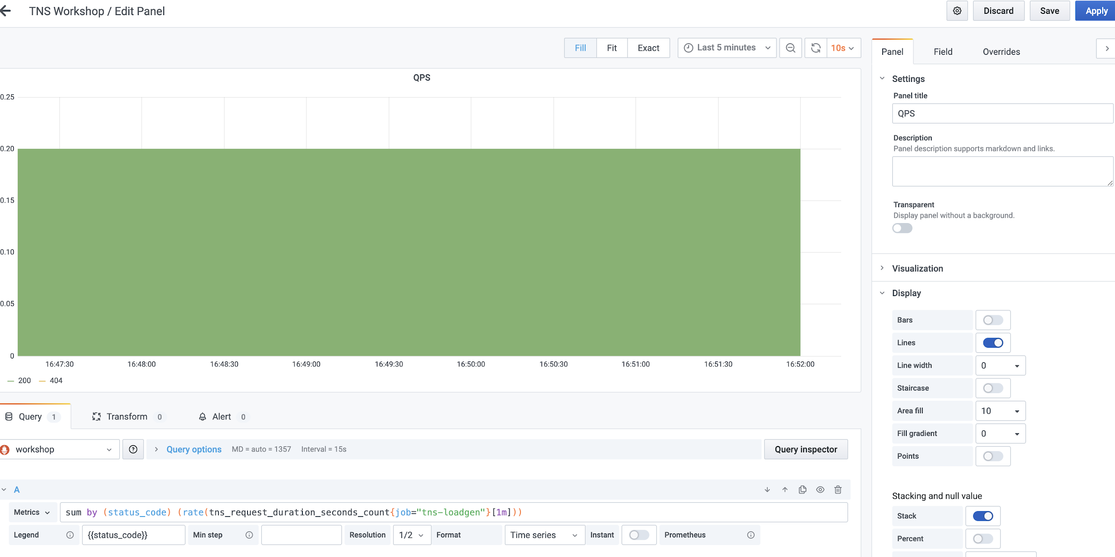

Click **Apply**.

Add another panel,

We will be using these three queries:

histogram_quantile(0.99, sum(rate(tns_request_duration_seconds_bucket{job="tns-loadgen"}[1m])) by (le)) * 1e3

**Legend**: 99th Percentile

Click the **Query** button to add query B:

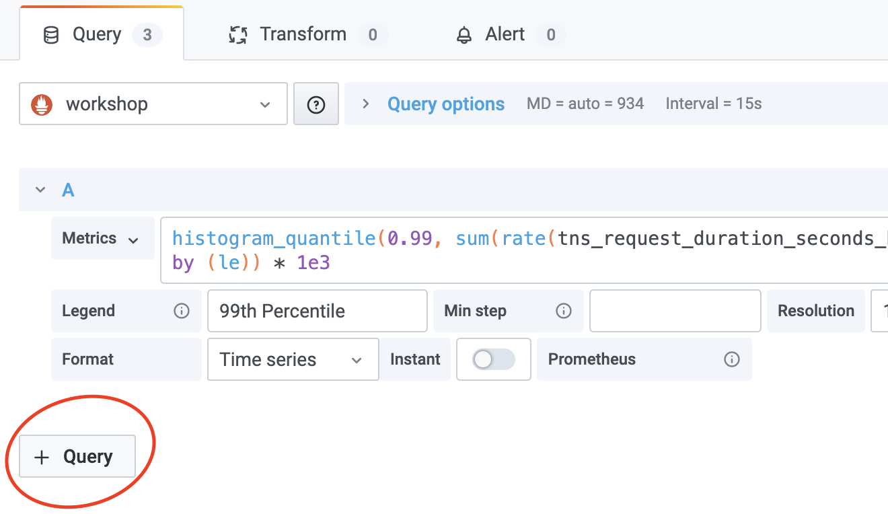

histogram_quantile(0.50, sum(rate(tns_request_duration_seconds_bucket{job="tns-loadgen"}[1m])) by (le)) * 1e3

**Legend**: 50th Percentile

sum(rate(tns_request_duration_seconds_sum{job="tns-loadgen"}[1m])) * 1e3 / sum(rate(tns_request_duration_seconds_count{job="tns-loadgen"}[1m]))

**Legend**: Average

Name the panel **Latency**.

And hit **Apply** on the top right:

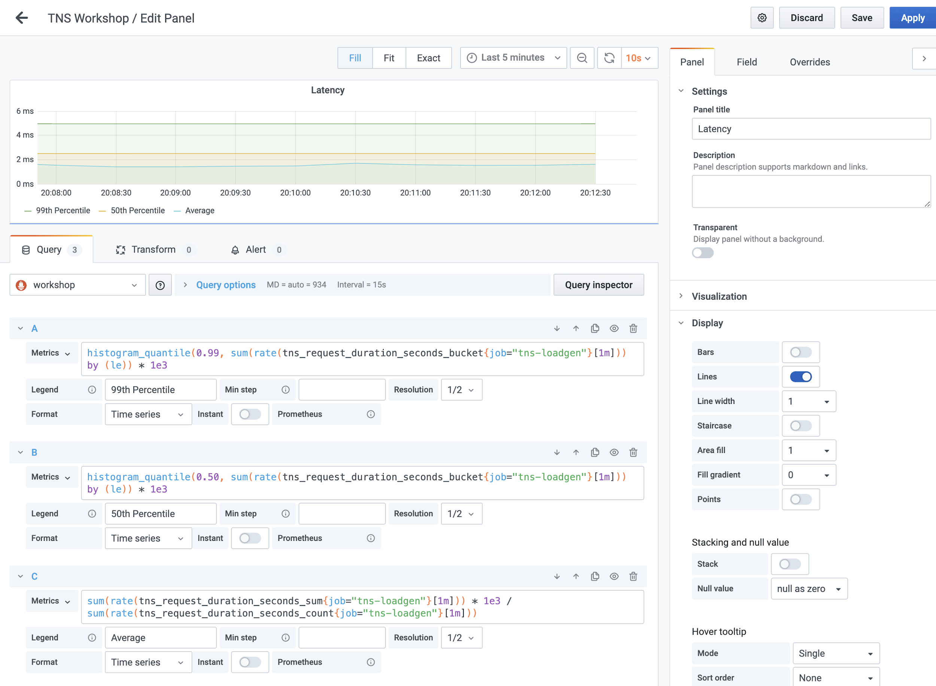

Now move the dashboard to the right using the drag and drop function.



Save the dashboard and title it “Workshop RED Method Dashboard.”

You should now have a row of two panels. Next, create four more new panels following the same steps but change the job names to tns-app for the second row and tns-db for the last row.

You can do this by adding individual panels, but I recommend duplicating the left panel twice and the right panel twice to end up with this:



Do duplicate click the panel title -> more, duplicate.

Once you have those panels, edit the middle two panels and change the job label to tns-app. Repeat for the last set of panels.

When you are done, you will have created a useful SRE dashboard giving you valuable insights into your service.

**References**:

Here is the completed JSON of the dashboard you can upload in the future:

<https://grafana.com/grafana/dashboards/13017>

* [Github repo for workshop demo](https://github.com/nikoalch/prom-workshop-101)
* [Cardinality is key](https://www.robustperception.io/cardinality-is-key)
* [SLO alerting recap](https://grafana.com/blog/2019/11/27/kubecon-recap-how-to-include-latency-in-slo-based-alerting/)
* [Google SRE Book](https://landing.google.com/sre/sre-book/toc/index.html)
* [Better histograms](https://grafana.com/blog/2020/08/24/kubecon-cloudnativecon-eu-recap-better-histograms-for-prometheus/)